|  |  |
| --- | --- |
| maynooth_new_logo | **Department of Electronic Engineering**  **EE204** |

## Title: Biasing a FET Transistor

## Number: 3

**EQUIPMENT**

A voltage source, voltmeters, a laboratory lead kit

A signal generator and an oscilloscope

**OBJECTIVE**

The purpose of this experiment is to demonstrate various biasing techniques for FET transistors

### PROCEDURE

**Part 1**

Using the same technique as before, apply a range of voltages to the gate of the PMOS below until you identify the transition voltage for the transistor.

The transistor should have a threshold voltage of magnitude approximately 2 volts but it can vary for different transistors. However, this will be unique to your transistor. Please record it in your report. (The VT voltage for a PMOS will be a negative number.)

Repeat the measurement for an NMOS transistor, the circuit is shown below.

**Note**: To identify VT, this is the gate-source voltage at which the transistor starts to conduct

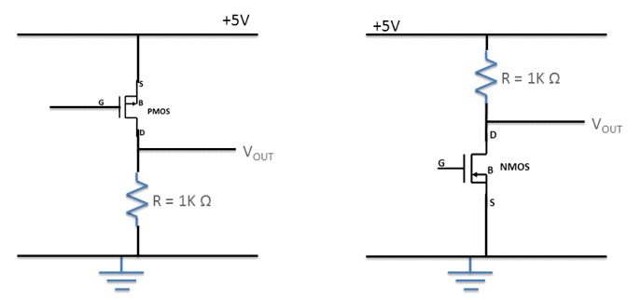

**Part 2**

In this section, please find a value of gate voltage (with respect to ground) that gives an equivalent large signal resistance of 1 kΩ. You can achieve this by changing the value of the voltage of the gate until you find that VOUT is equal to half that of the 5V (ie 2.5V) which is what you would expect with two equal valued resistances.

**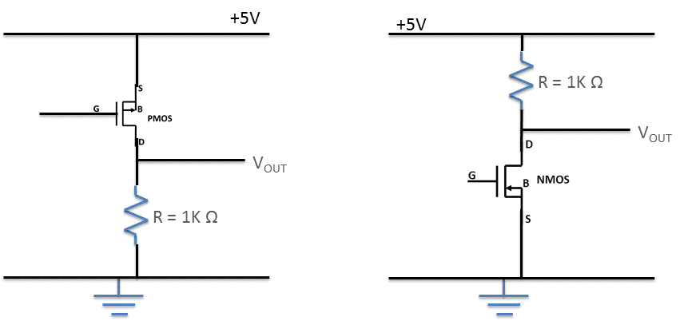**

Record the voltages in your report. Comment on whether the devices are in saturation or not. The answer to the last will depend on your transistor. Please make sure to explain your answer.

Saturation occurs when

VDS = VGS - VT

Repeat for both NMOS and PMOS devices.

**Part 3**

As no current flows into the gate of a FET, one of the easiest ways to bias a FET is to use a simple resistor divider. For your NMOS device, construct a bias circuit, in the form below, that would produce the same gate voltage as you identified in the previous part.

**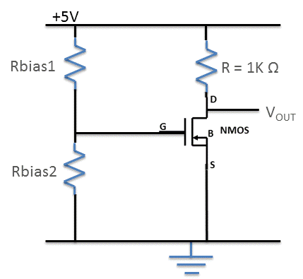**

State the value of the resistors used.

Calculate the current that flows through the resistors, include your calculations in your report.

To obtain the value of gate voltage needed, you just need to ensure the ratio of the two resistors. Would there be any benefit to going for very small resistors as compared to very big resistors. For example

1MΩ /5MΩ = 1Ω / 5Ω = 0.2

Explain your reasoning.

Part 4

Construct the following circuit.

**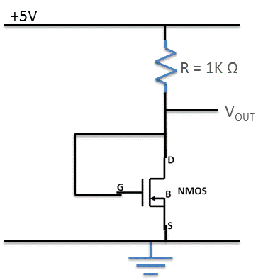**

Measure the gate and drain voltages, identify if the device is in saturation.

Determine the effective resistance of the transistor in this mode of operation.

Explain how this biasing circuit works, and under what conditions (eg values of VDS) will the transistor be in saturation.

### REQUIRED RESULTS IN REPORT

To be uploaded via moodle before the next laboratory

Please transcribe the results of the questions in the order of experiment

Your report should have the following structure

* A brief introduction showing you know what the lab is about (3-4 lines MAX)
* For each section you need the following
  + - A drawing of the circuits used
    - Your results
    - Comments and opinions on results or methods used.
* Conclude your report with a summary section which may include any additional conclusions you may have.

Late reports can be emailed to me but will incur penalties of 10% per day (or part of a day, weekends are counted the same as weekdays).

|  |
| --- |
| **Marks will be deducted for poorly presentation, poorly written reports.**  **Marks will only be awarded for sections completed.** |